# Flow Documentation - Flow_ProgramaFerias_Cadastro-8986B5A7-2CF3-EE11-A1FD-0022489FEA43

|  |  |
| --- | --- |
| **Flow Name** | Flow_ProgramaFerias_Cadastro-8986B5A7-2CF3-EE11-A1FD-0022489FEA43 |
| **Documentation generated at** | 22 May 2024 11:07 |
| **Number of Variables** | 0 |
| **Number of Actions** | 1 |

## Flow Overview

The following chart shows the top level layout of the Flow. For a detailed view, please visit the section called Detailed Flow Diagram

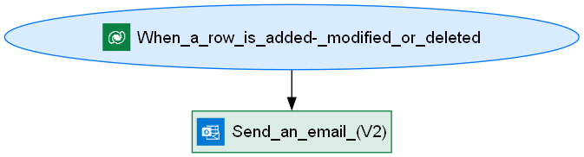

## Connections

There are a total of 2 connections used in this Flow:

### shared

|  |  |
| --- | --- |
| **Connector** | [shared](https://docs.microsoft.com/connectors/shared) |
| **Connection Type** | ConnectorReference |
| **Connection Reference Name** | cr058_sharedcommondataserviceforapps_cd24a |
| **Source** | embedded |

## Variables

## Trigger

|  |  |
| --- | --- |
| **Name** | When_a_row_is_added,_modified_or_deleted |
| **Type** | OpenApiConnectionWebhook |
| **Connector** | commondataserviceforapps |
| **Inputs Details** | |
| **parameters** | |  |  | | --- | --- | | subscriptionRequest/message | 1 | | subscriptionRequest/entityname | cr058_cadastro_ginasio | | subscriptionRequest/scope | 4 | |
| **host** | |  |  | | --- | --- | | apiId | /providers/Microsoft.PowerApps/apis/shared_commondataserviceforapps | | connectionName | shared_commondataserviceforapps | | operationId | SubscribeWebhookTrigger | |
| **authentication** | @parameters('$authentication') |

## Actions

There are a total of 1 actions used in this Flow:

### Send_an_email_(V2)

|  |  |
| --- | --- |
| **Name** | Send_an_email_(V2) |
| **Type** | OpenApiConnection |
| **Connection** | |  |  | | --- | --- | |  | [Office 365 Outlook](https://docs.microsoft.com/connectors/office365) | |
| **Inputs** | |
| **parameters** | |  |  | | --- | --- | | emailMessage/To | iefp230@alunos.ipca.pt; @{triggerBody()?['cr058_email']} | | emailMessage/Subject | Confirmação Inscrição | | emailMessage/Body | <p>Olá.<br><br>A sua inscrição foi registada.</p><br><br><p>Obrigada por escolher os nossos serviços.<br><br>Power Gym Girls</p> | | emailMessage/Importance | Normal | |
| **host** | |  |  | | --- | --- | | apiId | /providers/Microsoft.PowerApps/apis/shared_office365 | | connectionName | shared_office365 | | operationId | SendEmailV2 | |
| **authentication** | @parameters('$authentication') |

## Detailed Flow Diagram

The following chart shows the detailed layout of the Flow

